## Creation of Az Machine Learning model

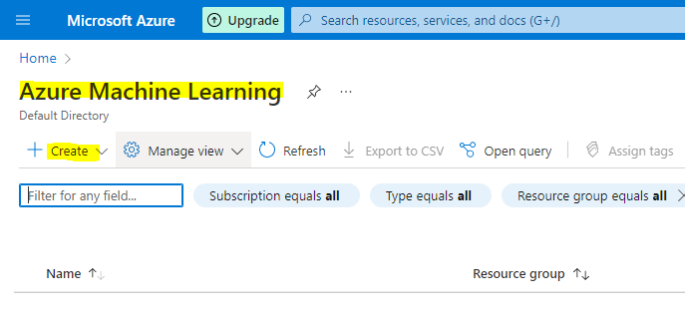

Select - New workspace option

The workspace is the top-level resource for your machine learning activities, providing a centralized place to view and manage the artifacts you create when you use Azure Machine Learning. The compute resources provide a pre-configured cloud-based environment you can use to train, deploy, automate, manage, and track machine learning models.

New Resource grp created - demo-ml

Once Review & create completed, deployment begins

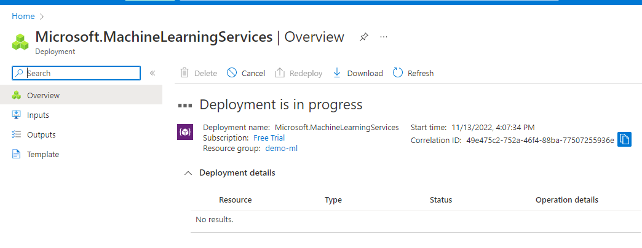

In Home page, select az ml workspaceAL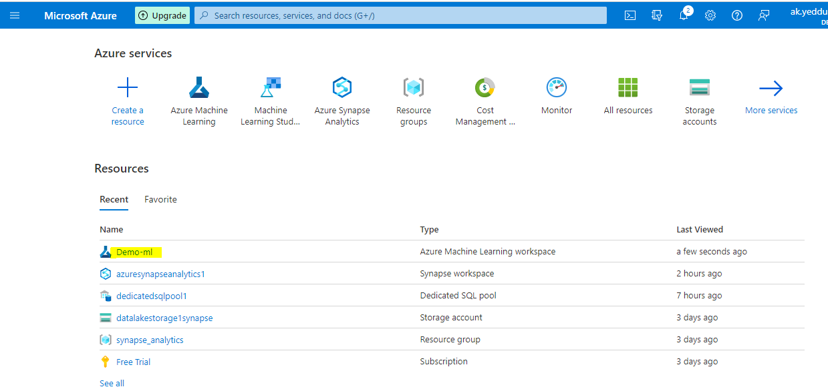

## Launch Studio

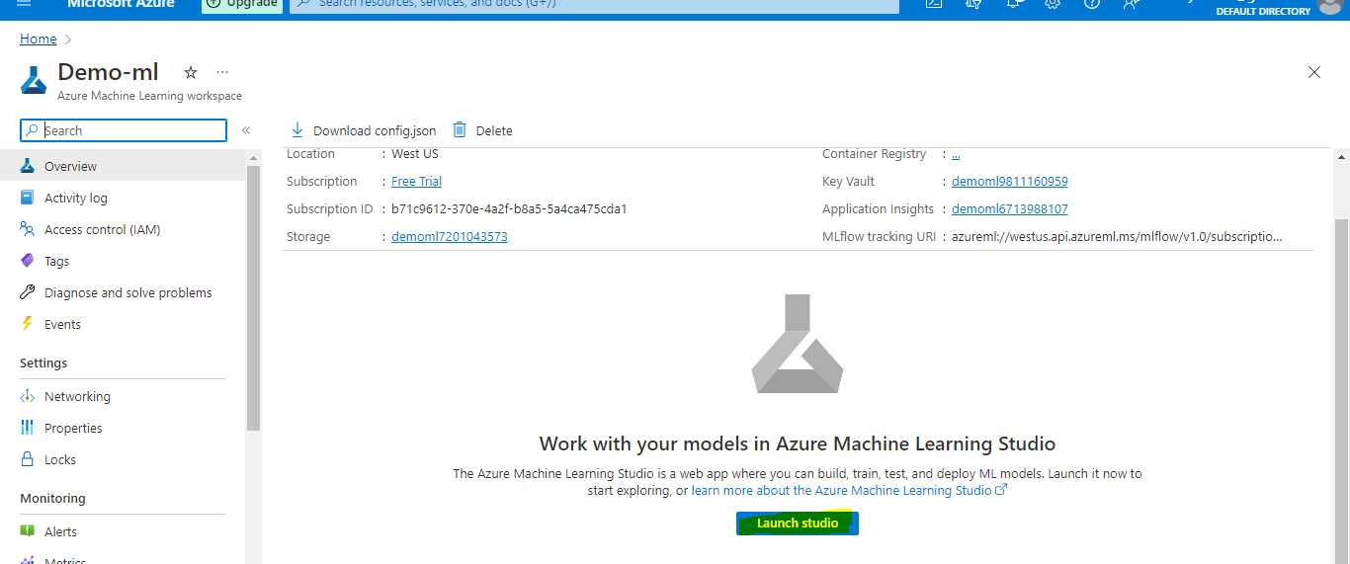

After Launch

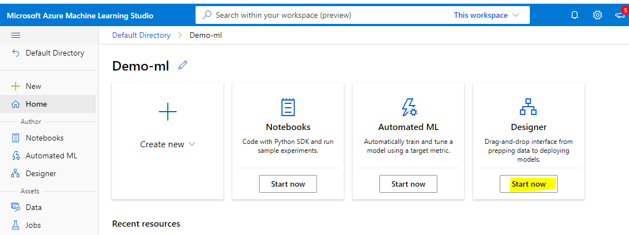

Will select Designer method to proceed

Designer -> Classic prebuilt

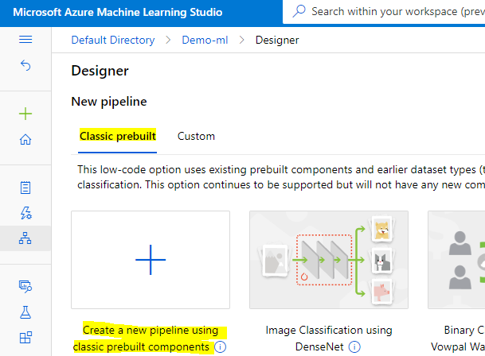

Selecting compute target as Compute cluster

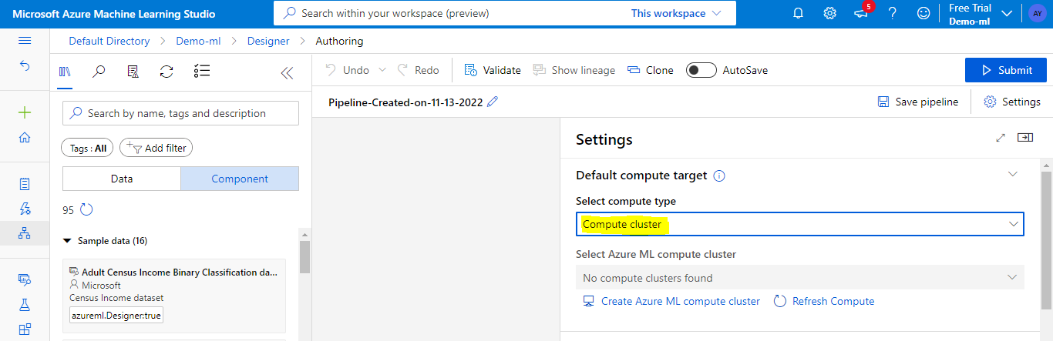

## Import Data

- use Automobile price data (Raw) from Sample data

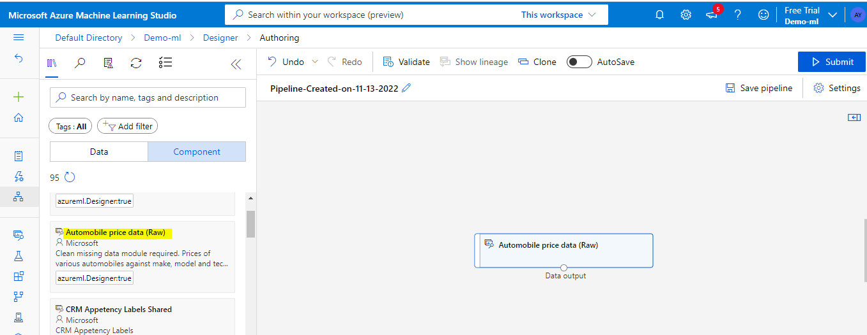

## Visualize data

We can visualize data by Right-clicking on the Automobile price data (Raw) and select Preview Data.

Also by clicking on col names,we can check the column specifications

There are 205 rows and 26 columns in this dataset.

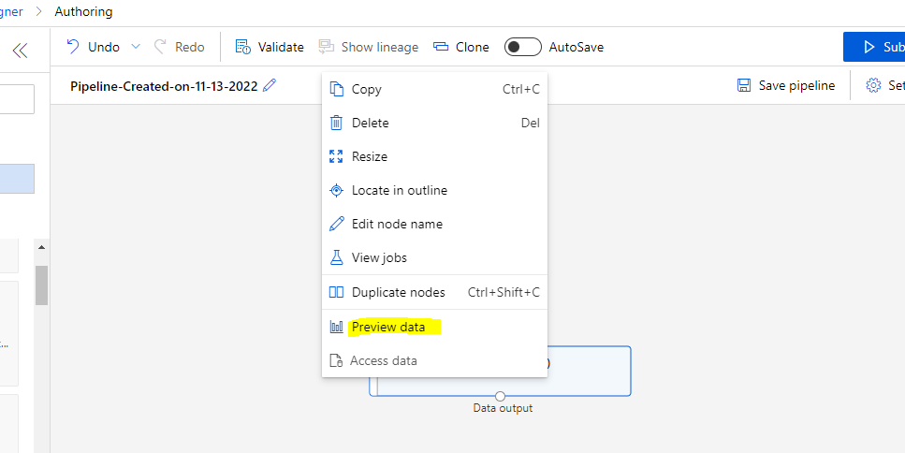

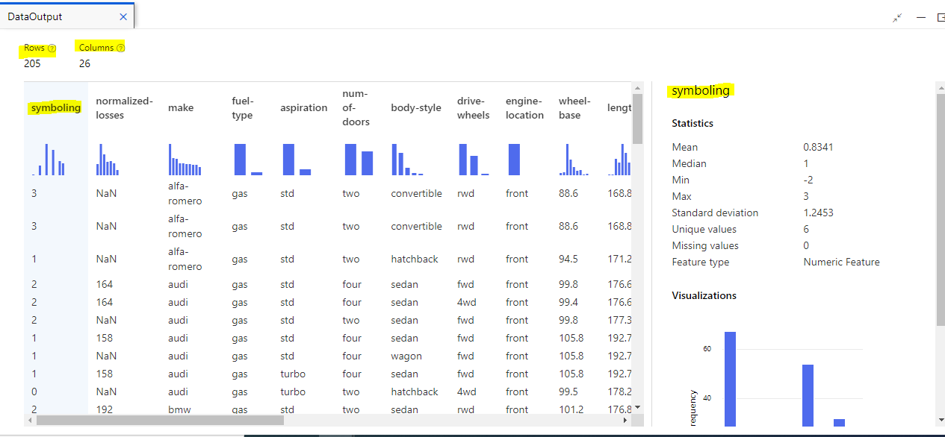

Prepare the data

## Remove a column

As there are few missing values, we will be cleaning the missing values so that the model can analyze the data correctly

In this dataset, the normalized-losses column is missing many values, so we'll exclude that column from the model altogether.

From Component, we are selecting the Select Columns in Dataset component.

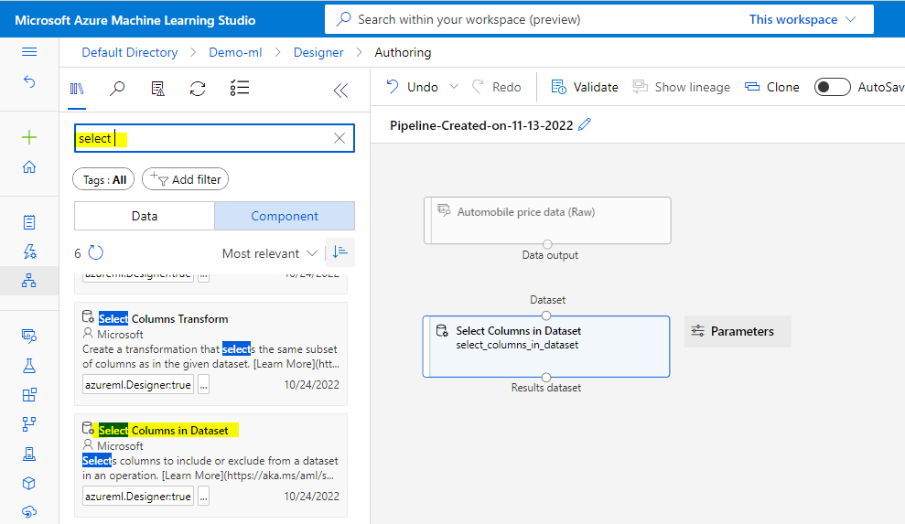

Connect the Automobile price data (Raw) dataset to the Select Columns in Dataset

Click on the arrow icon on the right side of the pane or double click on the Select col in the dataset.

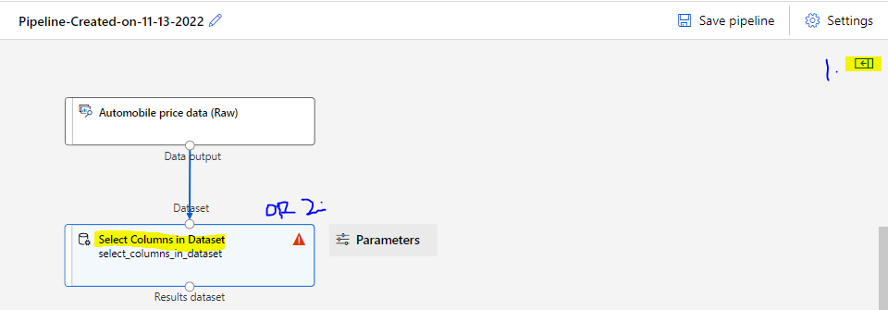

Edit column

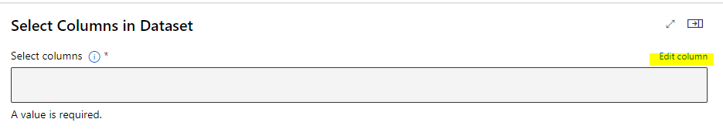

Select column normalized-losses to exclude & save

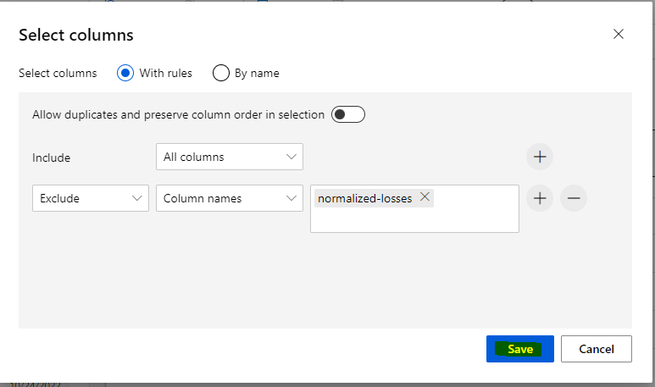

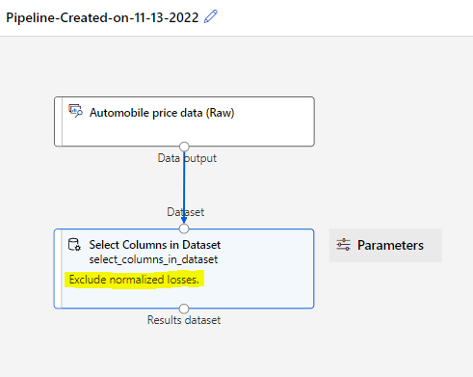

## Clean Missing Data

There are still missing values in a few columns. Now, will remove the remaining missing data by using the Clean Missing Data component.

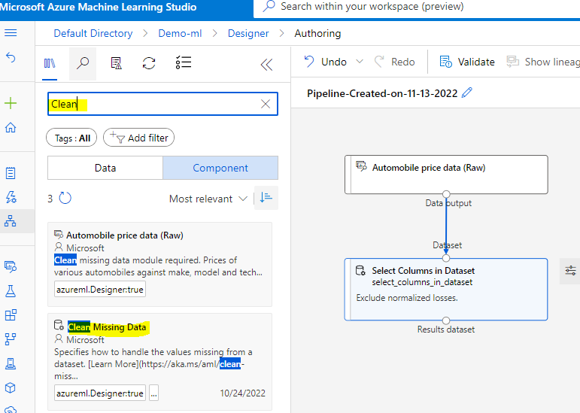

Connect Select col in Dataset to clear missing data

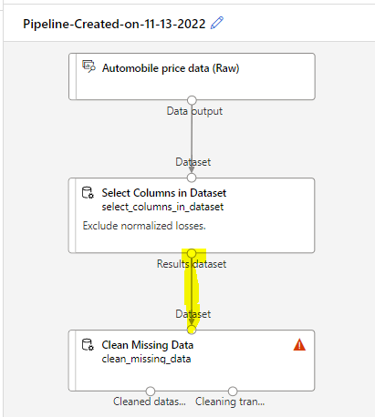

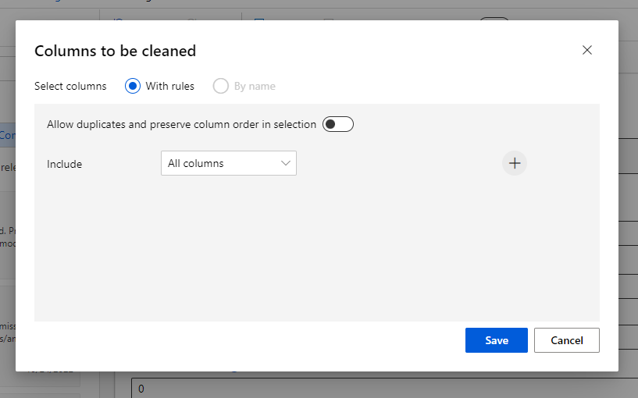

In the Clean Missing Data component details pane, under Cleaning mode, select Remove entire row.

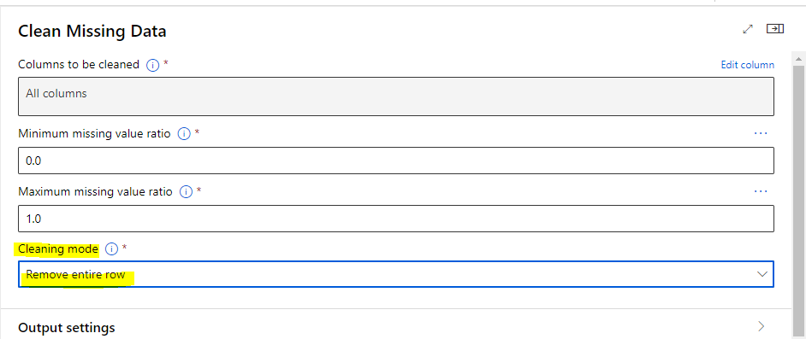

In the Node info:

Select the Comment text box and enter *Remove missing value rows*.

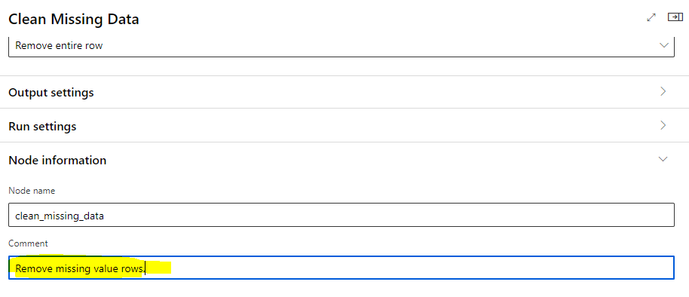

## Train a machine learning model

As we want to predict price, which is a number, we are using a regression algorithm. For this example, we will use a Linear Regression Model.

### 

### Split the data

* We split the data into Train & Test sets

1. So from Component, search for the Split Data component & drag in the canvas
2. Now, connect the left port of the Clean Missing Data component to the Split Data component. (The left port contains the cleaned data. The right port contains the discarded data.)

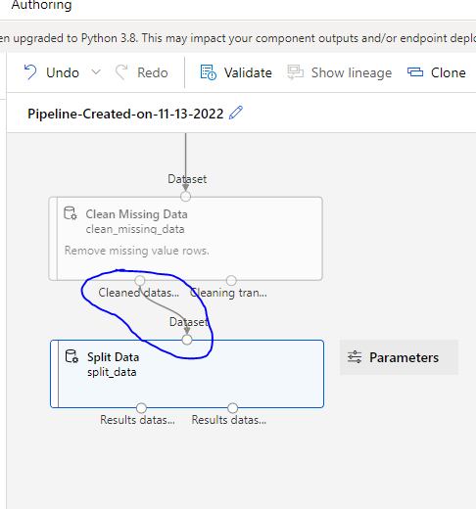

1. Now, we will Split Data component.In the Split Data details pane, set the Fraction of rows in the first output dataset to 0.7.
2. This option splits 70 percent of the data to train the model and 30 percent for testing it. The 70 percent dataset will be accessible through the left output port. The remaining data will be available through the right output port.

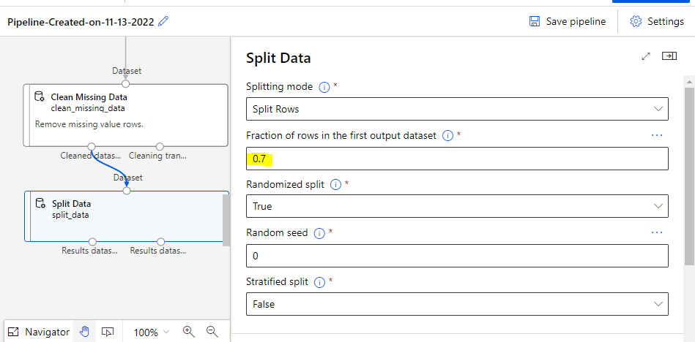

1. Mentioning comments in Node Info

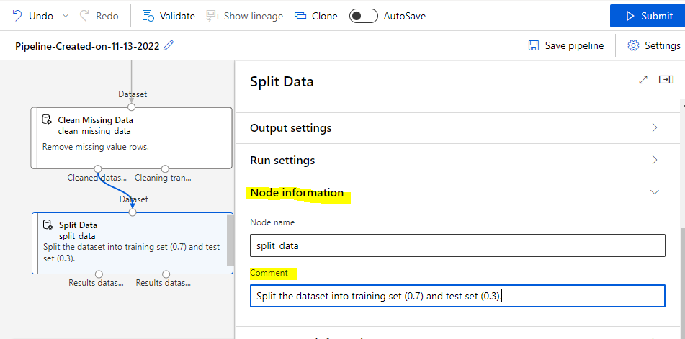

### Train the model

Train the model by giving it a dataset that includes the price. The algorithm constructs a model that explains the relationship between the features and the price as presented by the training data.

1. Now, click Component and search for the Linear Regression component & Train model component and drag it to canvas.
2. Connect the output of the Linear Regression component to the left input of the Train Model component.
3. Connect the training data output (left port) of the Split Data component to the right input of the Train Model component.
4. We need to make sure that the left output port of Split Data connects to the Train Model. The left port contains the training set. The right port contains the test set.
5. Now the pipeline will look like this

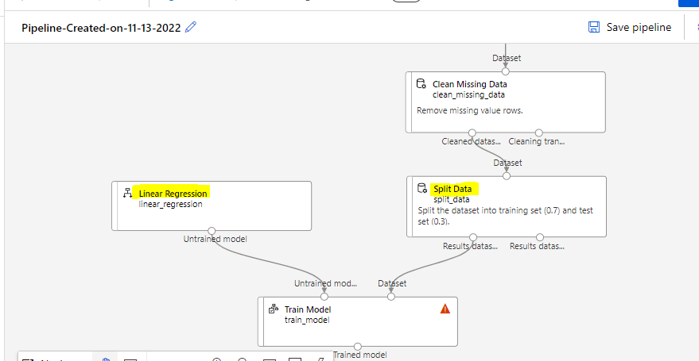

1. Open the Train Model component and select Edit column

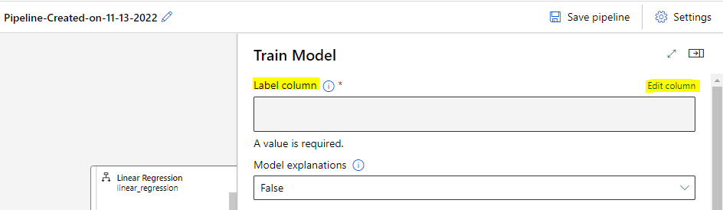

1. In the Label column window that appears, expand the drop-down menu and select Column names.
2. In the text box, enter **price** to specify the value that your model is going to predict.

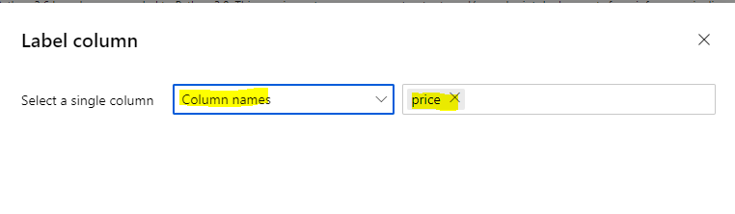

The pipeline now look like this:

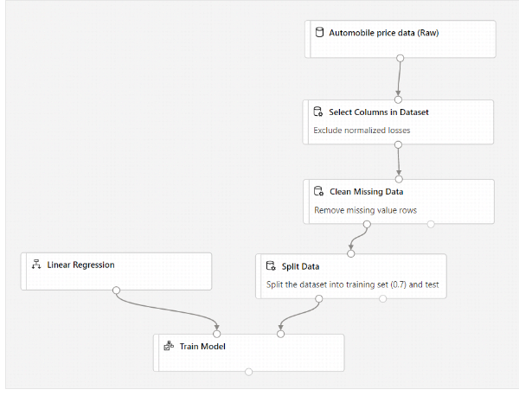

### Score Model component

After you train your model by using 70 percent of the data, you can use it to score the other 30 percent to see how well your model functions.

1. In the Component and search for the Score Model component & drag in canvas.
2. Connect the output of the Train Model component to the left input port of Score Model. Connect the test data output (right port) of the Split Data component to the right input port of Score Model.

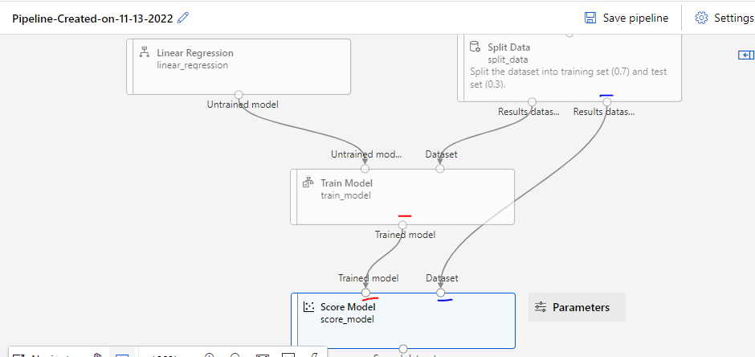

### Evaluate Model component

1. From Components, search for the Evaluate Model component and drag it in canvas.
2. Connect the output of the Score Model component to the left input of Evaluate Model.

The final pipeline should look something like this:

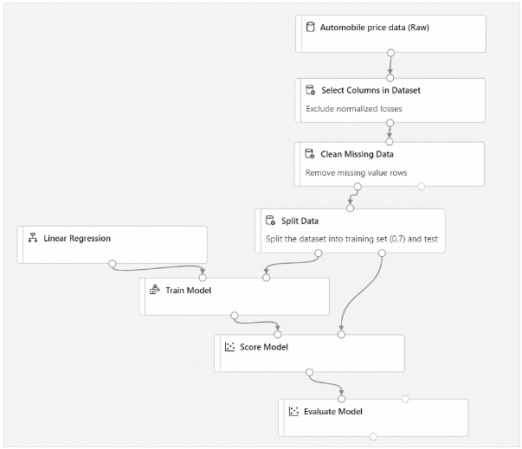

## 

## 

## 

## 

## 

## 

## Submit pipeline

At the top, we have submit button.

